**Assignment no.3**

**9)package** project3;

**public** **class** Nestedfor {

**public** **static** **void** main(String[] args) {

**int** i =1;

**int** j=1;

**for**(i=1;i<=5;i++)

{

**for**(j=1;j<=i;j++)

{

System.***out***.print("* ");

}

System.***out***.println("");

}

}

}

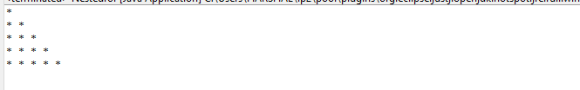

**package** project3;

**public** **class** Nestedfor {

**public** **static** **void** main(String[] args) {

**int** i =1;

**int** j=1;

**for**(i=1;i<=5;i++)

{

**for**(j=1;j<=i;j++)

{

System.***out***.print(" "+ i);

}

System.***out***.println("");

}

}

}

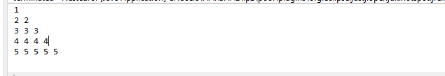

**package** project3;

**public** **class** Nestedfor {

**public** **static** **void** main(String[] args) {

**int** i =1;

**int** j=1;

**for**(i=1;i<=5;i++)

{

**for**(j=1;j<=i;j++)

{

System.***out***.print(" "+ j);

}

System.***out***.println("");

}

}

}

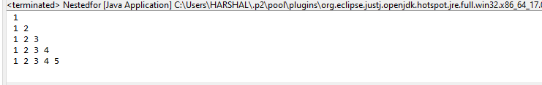

**package** project3;

**public** **class** Nestedfor {

**public** **static** **void** main(String[] args) {

**int** i =1;

**int** j=1;

**char** r='A';

**for**(i=1;i<=5;i++)

{

r='A';

**for**(j=1;j<=i;j++)

{

System.***out***.print(" "+r);

r++;

}

System.***out***.println("");

}

}

}

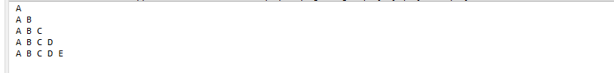

**package** project3;

**public** **class** Pattern1 {

**public** **static** **void** main(String[] args) {

**int** i =1;

**char** r='A';

**for**(i=1;i<=4;i++)

{

r='A';

**for**(**int** j=4;j>=i;j--)

{

System.***out***.print(" " + r);

r++;

}

System.***out***.println("");

}

}

}

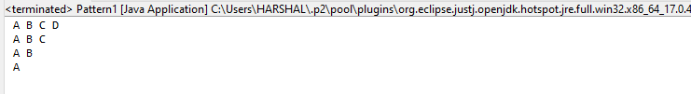

**1)package** project3;

**public** **class** onetohund {

**public** **static** **void** main(String[] args) {

**for**(**int** i=1;i<=100;i++)

{

System.***out***.print(i);

}

}

}

1 2 3 4 5 6 7 8 9 10 11 12 13 14 15 16 17 18 19 20 21 22 23 24 25 26 27 28 29 30 31 32 33 34 35 36 37 38 39 40 41 42 43 44 45 46 47 48 49 50 51 52 53 54 55 56 57 58 59 60 61 62 63 64 65 66 67 68 69 70 71 72 73 74 75 76 77 78 79 80 81 82 83 84 85 86 87 88 89 90 91 92 93 94 95 96 97 98 99 100

**2)package** project3;

**public** **class** evenno {

**public** **static** **void** main(String[] args) {

**for**(**int** i=1;i<=20;i++)

{

**if**(i%2==0)

{

System.***out***.print(" "+ i);

}

}

}

}

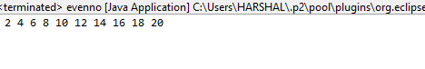

**3)package** project3;

**public** **class** cube {

**public** **static** **void** main(String[] args) {

**for**(**int** i=1;i<=5;i++)

{

System.***out***.print(" "+ i*i*i);

}

}

}

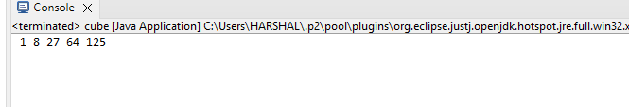

**7) package** project3;

**import** java.util.Scanner;

**public** **class** table {

**public** **static** **void** main(String[] args) {

**int** x;

Scanner s = **new** Scanner( System.***in***);

System.***out***.println("Enter value of x");

x = s.nextInt();

**for**(**int** i=1;i<=10;i++)

{

System.***out***.print(" " + i*x);

}

}

}

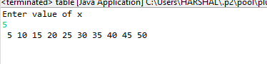

**8)** **package** project3;

**public** **class** Primerange {

**public** **static** **void** main(String[] args) {

**int** i;

**int** j;

**int** counter =0;

**for**( i=2;i<=20;i++)

{

**for**( j=1;j<=i;j++)

{

**if**(i%j==0)

counter ++;

}

**if** (counter==2)

{

System.***out***.print(" "+ i);

}

counter=0;

}

}

}

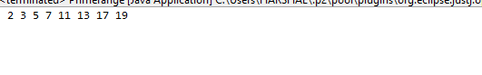

**5)package** project3;

**import** java.util.Scanner;

**public** **class** Fibonacci {

**public** **static** **void** main(String[] args) {

**int** num;

**int** i;

**int** a=0;

**int** b=1;

**int** c;

Scanner s = **new** Scanner(System.***in***);

System.***out***.println("Enter num:");

num= s.nextInt();

**for**(i=1;i<=num;i++)

{

System.***out***.print(" "+ a);

c=a+b;

a=b;

b=c;

}

}

}

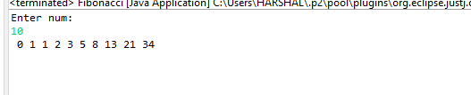

**6)package** project3;

**import** java.util.Scanner;

**public** **class** Factorial {

**public** **static** **void** main(String[] args) {

**int** fact=1;

**int** num;

**int** i;

Scanner s = **new** Scanner(System.***in***);

System.***out***.println("Enter num");

num= s.nextInt();

**for**(i=1;i<=num ;i++)

{

fact=fact*i;

}

System.***out***.println(fact);

}

}

